**INTERNSHIP REPORT**

###### AN INTERNSHIP WITH NETVISTA TECHNOLOGIES, BENGALURU

SUBMITTED IN PARTIAL FULFILLMENT OF THE REQUIREMENTS OF THE BACHELOR OF BUSINESS ADMINISTRATION DEGREE COURSE OF

BENGALURU CITY UNIVERSITY



###### BY

**EVALUATION OF INTERNSHIP REPORT**

**For Submission to Bengaluru City University**

|  |  |
| --- | --- |
| **Student** | **Mentor/Supervisor** |
| **Name:** | **Name:** |
| **Reg. No:** | **Signature:** |
| **Signature:** |
| **Date:** | **Date:** |

**Evaluation Summary**

|  |  |  |  |
| --- | --- | --- | --- |
|  | **Project Report** | **VIVA VOCE** | **Total** |
| **Maximum Marks** | **60** | **40** | **100** |
| **Marks Allotted** |  |  |  |
| **Name of Examiner:** | | **Signature:** | |

## CERTIFICATE

###### This is to certify that the Internship Report Titled “AN INTERNSHIP WITH NETVISTA TECHNOLOGIES, BENGALURU” is carried out by student of VI Semester BBA, bearing Register No under the Guidance of Department of Management. He has successfully completed his 4 Weeks organizational study. The student has attended the required guidance sessions held.

###### The Internship report is submitted to the Bengaluru City University in the Academic Year 2023-24, in partial fulfilment for successful completion of VI semester BBA and award of Business Administration Degree course of Bengaluru City University.

This is to certify that the content of this report on “**NETVISTA TECHNOLOGIES**” carried out by, student of VI semester BBA, bearing Register no is a bonafide work carried out by the student under my supervision during the academic year 2023-24 in partial fulfilment for the completion of VI semester BBA Degree of Bengaluru City University.

This Internship report is original work carried out by the said student and there is no plagiarism. This Internship report has not been submitted for the award of any other degree / diploma in this institution or any other institution.

**PLACE: BANGALORE**

**DATE: SIGNATURE OF THE GUIDE**

I hereby declare that this Internship report on **“AN INTERNSHIP WITH NETVISTA TECHNOLOGIES” is an original record** of my experience while conducting the internship study at **NETVISTA TECHNOLOGIES**

The organizational study was carried out by me, in partial fulfilment for the successful completion of VI semester BBA Course of Bengaluru City University. This report is not submitted to any other university for the award of any Diploma/Degree etc.

###### DATE: NAME OF THE STUDENT

###### 

###### PLACE: BENGALURU

I deem it my privilege to thank of the Department of Management, Jain College, for the guidance, cooperation and continuous support which have been vital for the completion of the internship report.

I will take pride and immense pleasure to express my gratitude to for granting me permission to do the internship report, and for their ample support, and valuable guidance that has enabled me to complete this internship.

I would like to extend my gratitude to my **Family and Friends** for providing me the resources, support, inspiration, and encouragement, necessary to complete the internship report.

I also want to thank all of those who have been involved directly or indirectly in the completion of the internship report.

**LIST OF CONTENTS**

|  |  |  |
| --- | --- | --- |
| **Chapter**  **No** | **Content** | **Page No** |
| **1** | **Introduction** |  |
| **2** | **Profile of the Organization** |  |
| **3** | **Functions/Operations of the Organization** |  |
| **4** | **Learning Outcomes, Suggestion and Conclusion** |  |
|  | **Bibliography** |  |
|  | **Annexure**   * **Log Sheet** * **Any other (Given by Company)** |  |

# Chapter - 1

# INTRODUCTION

* 1. **INTRODUCTION TO INDUSTRY**

Information technology (IT) services are services used by organizations to create, manage, and deliver information, next to assisting with other business functions. Services include consulting, software development, systems integration, as well as hardware deployment and education. As a whole, the broader market for IT services is made up of several segments, including outsourcing, managed services, security services, data management, and cloud computing.

Generally, the profitability of companies in the industry depends on their ability to innovate their services and grow their technical expertise. Indeed, both smaller and larger companies can compete in this industry: larger companies offer broader services and have a global reach, while smaller companies tend to position themselves in niche markets and tailor their offerings more specifically to customers' needs. The most substantially growing segment of IT services is cloud computing which drives IT-related innovation.

The IT services industry comprises various services and products that help organizations manage and optimize their information and business processes. The broader IT services market includes managed services, security services, data management, and cloud computing.

Statista provides a wide range of information on global and regional IT services markets, including data on industry trends and segments, as well as financial metrics and forecasts The IT services market is a strong and growing market in the global IT industry. In the long run, IT services will continue to be an integral part of a wide variety of industries and businesses as the products and services on offer facilitate and accelerate digital transformation. Moreover, the impact of COVID-19 on work environments emphasized the global need for reliable IT infrastructure and services to enable hybrid work models to succeed.

The IT industry is a broad, sweeping term that covers many information technology-oriented organizations. If you think about it, no organization (whether corporate or government or non-profit) can survive without IT.

Therefore, when we speak about the IT industry, we include all organizations or departments within organizations which develop, maintain or operate the Information Technology systems.

Broadly, we can come up with the following segments for IT organizations. Many organizations will have a presence in multiple segments.

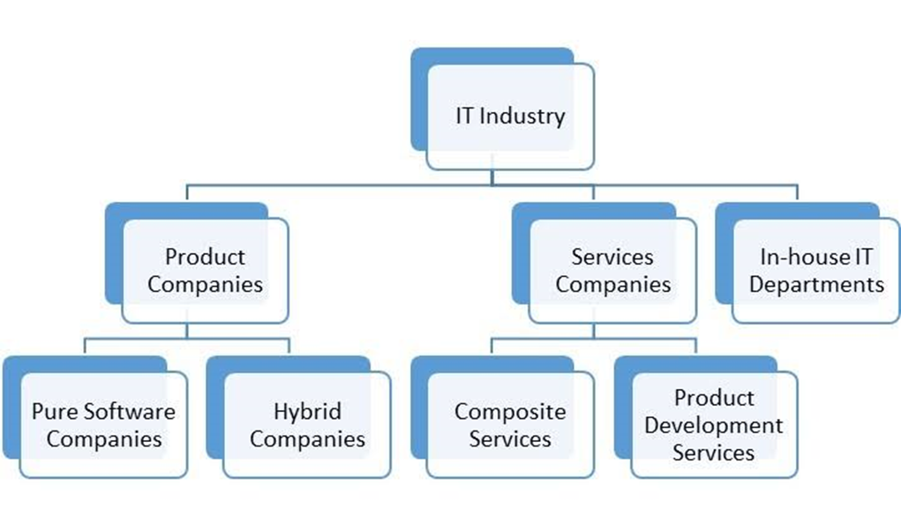

**Product Companies**: These are companies that work on products meant to serve a specific use for a customer. There could be pure software product companies (e.g. Adobe Systems or Computer Associates) or hybrid product companies which have both software and hardware - often bundled together but sometimes sold independently too (e.g. Google, Microsoft, Apple, etc.). Also included in this classification are the hundreds of thousands of small start-up companies looking to make their idea the next big idea.

**Services Organizations**: These organizations provide IT services to their customers.

They are some which specialize in providing services only to the product companies whereas others provide a wide range of services ranging from network maintenance, business process outsourcing, system support, and bespoke application development.

**In house IT department**: The IT function of some of the largest organizations may be bigger than many standalone IT companies. This function typically functions like a cost centre that provides IT services for the core business. For example, the IRCTC which serves the Indian railways builds and supports some of the most complex systems in the world.

* 1. **HISTORY OF IT INDUSTRY**

The history of the IT (Information Technology) industry is a fascinating journey marked by significant technological advancements, paradigm shifts, and the evolution of computing from its early beginnings to its pervasive presence in modern society. Here's a concise overview of key milestones and developments in the history of the IT industry:

### 1. Early Computing Era (1940s-1950s):

* **1940s:** The development of electronic computers began during World War II with machines like the Colossus, used by the British to break German codes. Meanwhile, in the United States, the ENIAC (Electronic Numerical Integrator and Computer) was developed as one of the earliest general-purpose electronic computers.
* **1950s:** The first commercially available computers emerged, including the UNIVAC I (Universal Automatic Computer), which became widely used for business and scientific applications.

### 2. Mainframe and Minicomputer Era (1960s-1970s):

* **1960s:** IBM introduced the IBM System/360, a family of mainframe computers that revolutionized computing by offering compatibility across different models. This era also saw the development of programming languages like COBOL and FORTRAN.
* **1970s:** The emergence of minicomputers, smaller and less expensive than mainframes, led to increased accessibility to computing power. Companies like DEC (Digital Equipment Corporation) and Hewlett-Packard became prominent players in the minicomputer market.

### 3. Personal Computer Revolution (1980s):

* **1980s:** The introduction of the IBM Personal Computer (PC) in 1981 marked the beginning of the personal computer revolution. The availability of affordable PCs, along with the release of the graphical user interface (GUI) by Apple with the Macintosh in 1984, popularized computing for individual users and small businesses.

### 4. Internet and World Wide Web (1990s):

* **1990s:** The proliferation of the internet and the development of the World Wide Web transformed the IT landscape. Tim Berners-Lee's invention of the HTTP protocol and the first web browser at CERN in 1991 laid the foundation for the modern internet. Companies like Netscape, Yahoo!, and Amazon played pivotal roles in popularizing the web and e-commerce.

### 5. Dot-Com Boom and Bust (Late 1990s-early 2000s):

* **Late 1990s:** The dot-com boom saw a rapid rise in internet-based companies and investments, fueled by optimism about the potential of the internet to revolutionize commerce and communication.
* **Early 2000s:** The dot-com bubble burst in the early 2000s, leading to the collapse of many internet startups and a market downturn. However, this period also saw the emergence of internet giants like Google and the continued growth of e-commerce.

### 6. Mobile and Cloud Computing Era (2000s-present):

* **2000s:** The rise of smartphones, led by devices like the iPhone and Android smartphones, revolutionized personal computing and internet access. Meanwhile, cloud computing emerged as a paradigm for delivering computing services over the internet, enabling scalable and on-demand access to resources.
* **2010s-present:** The IT industry witnessed further advancements in mobile technology, the proliferation of cloud services, the rise of big data analytics, and the advent of artificial intelligence (AI) and machine learning. Companies like Apple, Google, Amazon, Microsoft, and Facebook became dominant forces in the tech industry.

### 7. Current Trends and Future Outlook:

* **Artificial Intelligence:** AI and machine learning are driving innovation in areas like natural language processing, computer vision, and autonomous systems.
* **Internet of Things (IoT):** The IoT is connecting devices and enabling the collection and exchange of data for various applications, from smart homes to industrial automation.
* **Blockchain:** Blockchain technology is disrupting industries like finance, supply chain management, and healthcare with its decentralized and tamper-resistant ledger.
* **Cybersecurity:** With the increasing threat of cyberattacks, cybersecurity has become a critical focus area for IT companies and organizations worldwide.

The history of the IT industry is characterized by continuous innovation and disruption, with each era building upon the advancements of the previous ones. Looking ahead, emerging technologies like quantum computing, 5G, and augmented reality (AR) are poised to shape the future of IT, driving further transformation and growth in the industry.

* 1. **ORIGIN OF IT INDUSTRY**

The IT (Information Technology) industry traces its roots to the early 20th century with the emergence of mechanical and electromechanical computing devices, further accelerated by the demands of World War II for electronic computers. The commercialization of computing technology in the post-war era led to the development of mainframe computers, followed by the miniaturization and affordability of computing with the advent of microprocessors in the 1970s. The subsequent personal computer revolution, coupled with the rise of the internet and the World Wide Web in the 1990s, transformed the IT landscape, ushering in new business models and communication platforms. Since then, rapid advancements in hardware, software, networking, and telecommunications have propelled the IT industry forward, with innovations like cloud computing, mobile technology, big data analytics, artificial intelligence, and the Internet of Things reshaping how information is processed, accessed, and utilized across various sectors.

* 1. **TRENDS IN IT INDUSTRY**

1. **Cloud Computing Adoption:**

* Increasing reliance on cloud services for scalable and flexible access to computing resources.
* Offers benefits such as cost efficiency, agility, and scalability for businesses of all sizes.
* Shift towards cloud-native architectures and hybrid cloud environments.

1. **Artificial Intelligence (AI) and Machine Learning (ML):**

* Applications include natural language processing, computer vision, and recommendation systems.
* AI-driven insights are driving innovation and improving operational efficiency across various sectors.

1. **Cybersecurity Measures:**

* Heightened focus on cybersecurity to combat evolving cyber threats.
* Increased investment in advanced security solutions such as threat detection, encryption, and identity management.
* Emphasis on proactive threat intelligence and incident response strategies.

1. **Internet of Things (IoT):**
   * Utilized in various sectors including smart homes, healthcare, manufacturing, and transportation.
   * Drives demand for analytics and data management solutions to derive actionable insights.
2. **Edge Computing:**

* Growing adoption of edge computing for real-time data processing and analysis at the edge of networks.
  + Reduces latency and bandwidth usage for applications like autonomous vehicles and industrial automation.
  + Enables efficient and responsive processing for time-sensitive applications.

1. **5G Technology:**

* The rollout of 5G networks is enabling faster data speeds, lower latency, and increased connectivity.
* . Fuels innovation in areas like augmented reality (AR), virtual reality (VR), and Internet of Things (IoT) applications

1. **Blockchain Technology:**

* Applications include cryptocurrencies, supply chain management, digital identity verification, and smart contracts.
* Promotes transparency, immutability, and trust in transactions, driving innovation across various sectors.

1. **Data Privacy and Compliance:**

* Heightened focus on data privacy and regulatory compliance, driven by regulations like GDPR and CCPA.
  + Increased scrutiny on data handling practices, consent management, and data protection measures.
  + Organizations investing in data governance, encryption, and compliance management solutions to mitigate risks.

1. **Sustainability and Green IT:**
   * Adoption of green IT practices such as energy-efficient hardware, virtualization, and cloud computing to reduce carbon footprint.
   * Integration of sustainability considerations into IT procurement, data center operations, and product design processes
2. **Digital Transformation Acceleration:**

* Accelerated digital transformation initiatives across industries to adapt to changing market dynamics and consumer behaviors.
  + Emphasis on digitization of processes, customer experiences, and business models to enhance agility and competitiveness.
* Investment in emerging technologies and digital capabilities to drive innovation and business growth.
  1. **IMPACT ON GDP**

The Indian IT Services sector stands as a cornerstone of the country's economy, showcasing remarkable growth and contribution to various facets of national development. With a workforce of approximately 4.5 million people, the sector has emerged as a significant employer, albeit grappling with soaring attrition rates across all levels. It has been a pivotal force in India's economic transformation, with its contribution to GDP steadily rising from 1.2% in 1998 to a substantial 10% in 2019. Export-oriented, the sector dominates global markets, with the United States alone accounting for two-thirds of its IT services exports. This dominance is reflected in the industry's share of total Indian exports, soaring from under 4% in FY1998 to about 25% in FY2012. Technologically inclined, it encompasses 40% of the country's GDP and 30% of export earnings, all while employing just a quarter of the workforce, signifying its efficiency and productivity. Led by industry giants like Tata Consultancy Services (TCS), Infosys, Wipro, Tech Mahindra, and HCL Technologies, the sector faces fierce competition, particularly in talent acquisition and retention amidst the backdrop of rising attrition rates and escalating global demand. Yet, concerns linger over the advent of automation and artificial intelligence (AI), potentially disrupting traditional job roles within the industry. Despite these challenges, the Indian IT Services sector continues to stand resilient, driving economic growth, technological innovation, and global competitivenes

# CHAPTER-2

**PROFILE OF THE ORGANIZATION**

* 1. **NAME OF THE ORGANISATION**

Netvista technologies

* 1. **PROFILE OF THE ORGANISATION**

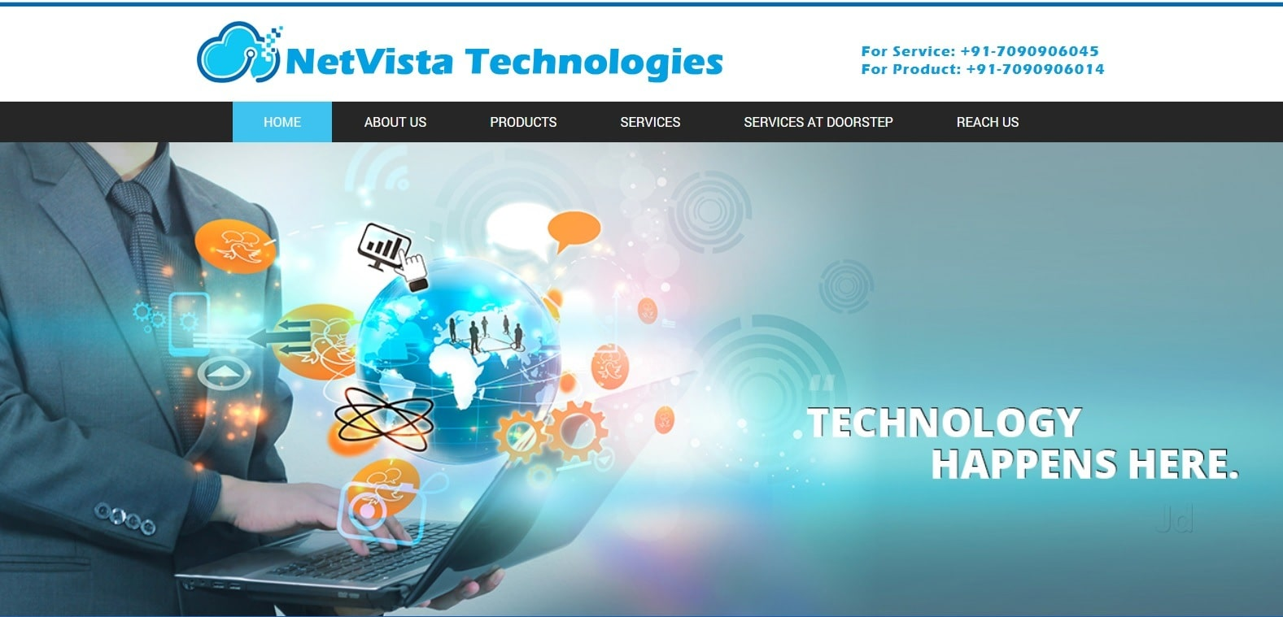

NetVista Technologies is your go-to partner for navigating the intricate realm of IT products and services. With a steadfast commitment to understanding and addressing the unique needs of our customers, we have developed a professional system dedicated to ensuring a seamless experience from initial consultation to ongoing support. Our comprehensive range of information technology services caters to businesses and individual users alike, covering everything from computer and network support to cybersecurity solutions and cloud computing services. What sets us apart is our customer-centric approach, where we prioritize satisfaction and tailor our solutions to fit the specific requirements of each client. Backed by a team of highly skilled and experienced professionals, we deliver quality services without compromise, guaranteeing both the integrity of our work and the reliability of our employees. At NetVista Technologies, affordability and timeliness go hand in hand with excellence, ensuring that our clients receive expert, customized, and friendly service that meets their needs and budget.

* 1. **COMPANY VISION**
* The Vision is to be the leader in IT services by enabling our business partners to achieve long-term success using our innovative and comprehensive IT solutions.
* Our vision is to build and secure a leading position in the expanding ICT industry by providing best-of-breed products and services to enable our partners and customers to compete effectively using the latest technologies.
* We dedicate ourselves to be the supplier of choice when our type of products is being sought.
* This vision will be accomplished by sharing the responsibilities of planning and decision making with all of our employees.
* Our company will strive to maintain the image it has developed over the many years with its suppliers, employees and community as a company of excellence.
* To build a better world with Information Technology
  1. **COMPANY MISSION**
* Provide best-of-breed hardware products and quality services to empower individuals and organizations for improved operations.
* Focus on becoming a highly credible and productive Information Technology service company, backed by customer care.
* Offer best-of-breed software products to enable organizations to enhance their business operations.
* Deliver effective IT solutions and quality services to enhance the competitive advantages of our clients.
* Maintain a sustainable social environment and act as a socially responsible corporate citizen.
* Prioritize fairness and transparency, offering upfront and transparent pricing and taking responsibility for service outcomes.
* Internally emphasize growth and continuous improvement, preparing employees to tackle challenges and advance in their careers.
  1. **DEPARTMENTS IN COMPANY**

### ****1.Development and Engineering****

### This department focuses on designing, developing, and testing software and applications. It includes roles such as software developers, engineers, testers, and quality assurance specialists.

### 2. ****Information Technology (IT) Support****

### IT support handles the company's internal tech infrastructure, including network management, hardware maintenance, and helpdesk services. This department ensures smooth day-to-day operations and addresses any technical issues employees face.

### 3. ****Sales and Marketing****

### Responsible for promoting and selling the company's products or services. The sales team works on client acquisition and retention, while the marketing team handles market research, branding, advertising, and digital marketing strategies.

### 4. ****Human Resources (HR)****

### The HR department manages recruitment, onboarding, employee relations, training, performance management, and benefits. They ensure the company attracts, retains, and develops talent.

### ****Finance and Accounting****

### This department manages the company’s financial health, including budgeting, financial reporting, payroll, accounts payable and receivable, and investment strategies. They ensure financial compliance and optimize financial performance.

### ****Customer Support****

### The customer support department provides assistance to clients, resolving technical issues and answering queries about products and services. This team is essential for maintaining customer satisfaction and loyalty

### NUMBER OF EMPLOYEES

Total Employees 15

We have a sales team consists of 4 employees

Our Financial work is outsourced to other company

We have total of 10 engineers

One General Manager

* 1. **ADRESS OF COMPANY**

Netvista Technologies

1st Floor, No. 9, Major Sandeep Unnikrishnan Road Aditya Nagar, State Bank of India, Vidyaranyapura, Bengaluru-560097, Karnataka, India

* 1. **SWOC ANNALYSIS**

#### **STRENTH**

* **Existing Customers**: Recurring revenue from existing customers provides a stable income stream.
* **Market Share**: Strong presence in Bangalore with a significant market share.
* **Cost Efficiency**: Lower operating costs compared to larger competitors, leading to better cost efficiency.
* **Skilled Personnel**: Highly skilled workforce, recognized as experts in their fields.
* **Diversified Customer Base**: Broad customer base, including both companies and the general public.
* **Employment and Training**: Opportunities for employment and professional development in the field.
* **Competitive Pricing**: Lower charges compared to competitors, making services more attractive.
* **Partnerships**: Collaborations with Justdial and UrbanClap to attract new customers.
* **Educated Workforce**: Well-educated and skilled labor force.

#### **WEAKNESS**

* **Customer Acquisition**: Challenges in attracting new customers.
* **Competition**: Difficulties in competing with major market players.
* **Large Contracts**: Difficulty in securing large contracts externally.
* **Out-of-City Service**: Reduced profit margins for services provided outside the city.
* **Career Prospects**: Need for better long-term career prospects to improve staff retention.
* **Marketing Costs**: High expenditure required for marketing efforts.

#### **OPPORTUNITY**

* **Growing Technology Dependence**: Increasing reliance on technology by people, expanding the potential customer base.
* **Market Adaptability**: Ability to quickly adapt to new market changes.
* **Partnerships**: Potential to form partnerships with other companies on various projects.
* **Word-of-Mouth**: Large customer base can help attract new customers through referrals and positive word-of-mouth.

#### **CHALLENGES**

* **Capital Requirements**: Significant capital needed to compete with larger companies.
* **Competition**: High competition makes attracting new customers challenging.
* **Employee Retention**: Difficulty in retaining employees for long durations.
* **Technological Advancements**: Challenges in keeping up with rapid advancements in technology.

NetVista Technologies has several strengths, including a stable customer base, strong market share in Bangalore, and a highly skilled workforce. The company benefits from cost efficiency, diversified customers, competitive pricing, and strategic partnerships. However, it faces challenges in acquiring new customers, competing with larger firms, securing large contracts, and retaining employees. Despite these weaknesses, there are opportunities for growth due to increasing dependence on technology and the potential for new partnerships. However, significant capital investment is required to remain competitive and adapt to technological advancements.

# CHAPTER-3

**FUNCTIONS AND OPERATIONS OF THE ORGANIZATION**

* 1. **COMPANY PRODUCTS**

**1.Desktop computer**

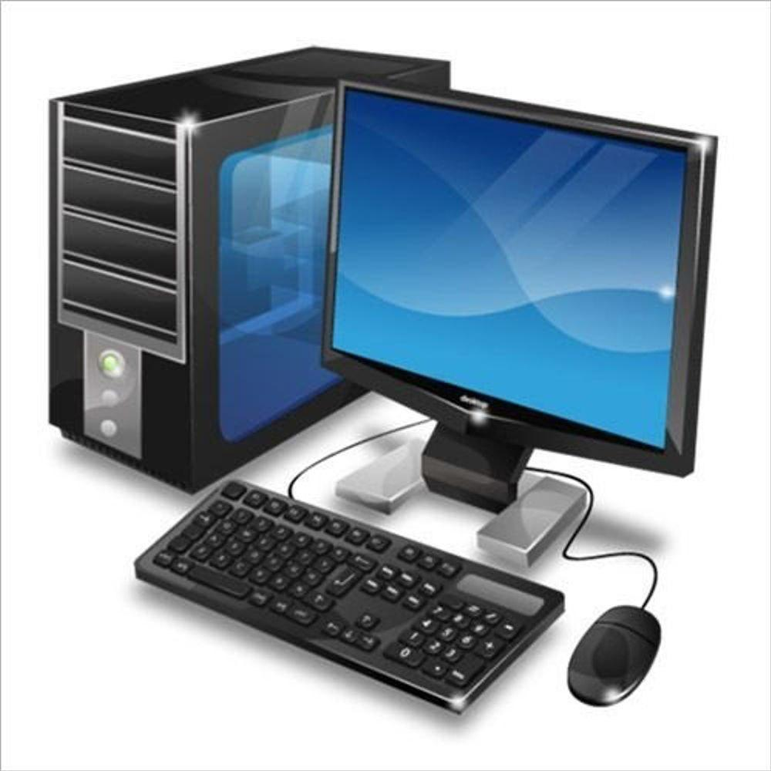

**Branded Desktop Computers and All-in-One Systems:**

* + **Reliability**: Products sourced from reputable manufacturers like HP, Dell, Lenovo, and Acer ensure reliability and quality.
  + **Performance**: These systems are equipped with powerful processors, ample RAM, and high-quality components to deliver smooth performance.
  + **Innovative Features**: Branded desktops and all-in-one systems come with innovative features such as touchscreen displays, ergonomic designs, and advanced cooling systems.

**Customized Assembled Computers:**

* + **Tailored Configuration**: Customers can specify their desired components, including CPU, GPU, RAM, storage, and peripherals, to meet their specific requirements.
  + **Budget-Friendly Options**: NetVista Technologies offers customization options to suit various budget constraints, ensuring customers get the best value for their money.
  + **Flexibility**: Customized assembled computers provide flexibility in terms of upgrades and future expansion, allowing customers to adapt their systems as their needs evolve.

**Gaming PC Features:**

* + **High-Performance Graphics**: Gaming PCs are equipped with dedicated graphics cards from leading manufacturers like NVIDIA and AMD to deliver immersive gaming experiences.
  + **Fast Processing**: Powerful processors and ample RAM ensure smooth gameplay and fast loading times, even for demanding titles.
  + **Customizable RGB Lighting**: Some gaming PCs feature customizable RGB lighting for a personalized gaming setup.

**Graphics Design Workstation Features:**

* + **Professional-Grade Graphics**: Graphics design workstations are equipped with high-performance GPUs optimized for rendering and graphic-intensive tasks.
  + **Color-Accurate Displays**: Workstations feature high-resolution displays with accurate color reproduction for precise color editing.
  + **Fast Storage**: SSDs or NVMe drives provide fast read/write speeds, reducing loading times for large design files.

**Remote Work/Online Classes PC Features:**

* + **Reliable Connectivity**: Computers for remote work or online classes feature built-in Wi-Fi and Ethernet connectivity for seamless online collaboration.
  + **Webcam and Microphone**: Integrated webcam and microphone ensure clear video conferencing and online communication.
  + **Productivity Software**: Pre-installed productivity software such as Microsoft Office suite enhances productivity for work or study.

1. **Billing software**

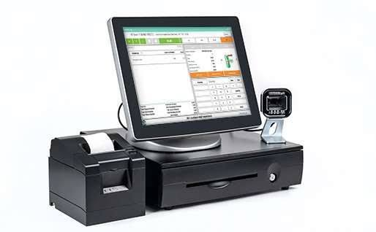

At NetVista Technologies, we offer a selection of top-notch billing software solutions, including Tally Prime, Busy, Marg, and Vyapar Software. These options cater to various business needs, from billing and inventory management to accounting and GST compliance. We provide comprehensive support, including software implementation and staff training, to ensure seamless integration and optimal utilization for our clients.

**Tally Prime:**

* + **Comprehensive Accounting Solution**: Tally Prime is a widely used accounting software known for its comprehensive features, including billing, inventory management, and GST compliance.
  + **User-Friendly Interface**: With an intuitive interface and easy-to-use tools, Tally Prime streamlines day-to-day business operations, making billing and inventory management simple and efficient.
  + **GST Compliance**: Tally Prime automates GST compliance processes, helping businesses generate accurate GST returns and stay compliant with tax regulations.
  + **Implementation and Training**: NetVista Technologies provides end-to-end support, including software implementation and training for staff members to ensure they can effectively utilize Tally Prime for their business needs.

**Marg:**

* + **Integrated Business Solution**: Marg is an integrated business solution that combines billing, inventory management, accounting, and GST compliance into a single platform.
  + **Advanced Features**: Marg offers advanced features such as barcode integration, financial analysis tools, and multi-location inventory management, making it suitable for businesses with complex operations.
  + **Cloud-Based Option**: Marg provides a cloud-based option for businesses looking for flexibility and scalability, allowing access to data from anywhere, anytime.
  + **Training and Support**: NetVista Technologies offers training and support services for Marg software, ensuring that businesses can maximize the benefits of the platform.

**Vyapar Software:**

* + **Simplified Billing and Accounting**: Vyapar Software is designed to simplify billing and accounting processes for small and medium-sized businesses, offering a user-friendly interface and essential features.
  + **Mobile Accessibility**: Vyapar Software offers mobile accessibility, allowing users to manage billing and accounting tasks on-the-go through mobile applications.
  + **GST-Compliant Invoicing**: Vyapar Software supports GST-compliant invoicing, making it easy for businesses to generate GST-compliant invoices and manage tax calculations.
  + **Implementation Assistance**: NetVista Technologies provides implementation assistance and training for Vyapar Software, ensuring that businesses can quickly adapt to and leverage the platform for their billing and accounting needs.

1. **Laptop**

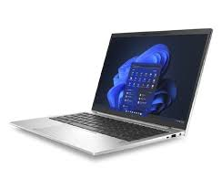

In the ever-evolving digital era, where online activities have become the norm, the significance of a dependable laptop has soared. Whether you're a professional adapting to remote work or a student navigating academic pursuits, NetVista Technologies ensures you're equipped with the right tool. At our office, our experts will assist you in selecting a laptop tailored to your needs, offering a plethora of features:

**Performance**: Our laptops boast powerful processors and ample RAM to handle tasks seamlessly.

**Connectivity**: Stay connected with Wi-Fi and Bluetooth capabilities for seamless communication.

**Portability**: Lightweight and sleek designs ensure easy mobility for on-the-go usage.

**Battery Life**: Enjoy long-lasting battery life to support extended work or study sessions.

**Display**: Crisp and vibrant displays provide an immersive viewing experience for work or entertainment.

**Storage**: Ample storage options cater to your data storage needs, ensuring you have ample space for files and documents.

**Accessories**: We offer a range of accessories including bags, mouse, and adapters to complement your laptop usage.

**Customization**: Tailor your laptop with options for upgrades and customization to suit your preferences.

1. **Additional products**

**Desktop Peripherals:** Wired or wireless keyboard and mouse options available.

**Laptop Peripherals:** Batteries, adaptors, and other essential accessories.

**Printers & Consumables:** Printers for various needs along with ink cartridges and toners.

**Storage Peripherals:** Internal and external hard disks, as well as pen drives.

**Networking Peripherals:** UPS systems, webcams, networking cables, switches, routers, Wi-Fi

**Racks and Networking Devices:** Networking racks and a range of networking devices.

**Storage Solutions:** Direct Attached Storage (DAS) and Network Attached Storage (NAS) solutions.

* 1. **COMPANY SERVICES**

### Desktop Services:

* Repair and servicing for desktop computers.
* Resolution of operating system-related issues.
* Addressing software-related issues.
* Upgrading desktop systems for improved performance.
* Resolving driver-related issues.
* Installation and management of antivirus software and data backup solutions.
* Comprehensive data recovery services for damaged or corrupted storage devices including internal and external hard disks, pen drives, and memory cards.
* Server and operating system management services including monitoring, performance management, troubleshooting, security management, patch management, backup management, user account management, and remote administration.

### Laptop Services:

* Repair and servicing for laptops, including chip level service.
* Resolution of operating system-related issues.
* Addressing software-related issues.
* Upgrading laptops to enhance performance.
* Resolving driver-related issues.
* Installation and management of antivirus software and data backup solutions.

### CCTV & Security:

* Installation of new CCTV setups.
* Servicing and maintenance of existing CCTV setups.
* Upgrading CCTV systems for improved performance.
* Ongoing maintenance and AMC (Annual Maintenance Contract) services.

### Networking Services:

* Planning and implementation of customized network solutions.
* Designing network architecture and implementing network infrastructure.
* Building networks and cabling infrastructure.
* Implementing network security measures.
* Providing network administration services.

At NetVista Technologies, we offer comprehensive services to ensure the smooth operation and maintenance of desktop and laptop systems, as well as the security and efficiency of CCTV setups and network infrastructure.

**Other services**

### Domain Name Services:

* **Domain Name Registration:** Assistance in registering domain names for your business, including top-level domains (TLDs) like .com, .net, .org, and country-code TLDs (ccTLDs).
* **Domain Name Selection:** Expert guidance in choosing a domain name that aligns with your brand identity, reflects your business's values, and is memorable for your target audience.
* **Domain Name Management:** Ongoing management of domain names, including renewal, DNS configuration, and domain transfer assistance.

### Business Mail Services:

* **Professional Email Setup:** Configuration and setup of professional email addresses using your domain name (e.g., yourname@yourbusiness.com).
* **Custom Email Hosting:** Hosting of business email accounts on reliable servers with robust security features and ample storage space.
* **Email Client Configuration:** Assistance in configuring email clients (e.g., Outlook, Thunderbird) for seamless access to business email accounts.

### Website Design Services:

* **Custom Website Design:** Creation of custom-designed websites tailored to your business's unique requirements, preferences, and branding guidelines.
* **Responsive Design:** Development of websites optimized for viewing on various devices, including desktops, laptops, tablets, and smartphones.
* **User Experience (UX) Design:** Focus on creating an intuitive and user-friendly website interface to enhance user satisfaction and engagement.
* **Content Management Systems (CMS):** Integration of CMS platforms like WordPress, Joomla, or Drupal for easy content management and updates.

### Hosting Services:

* **Website Hosting:** Provision of reliable and secure website hosting services on high-performance servers with guaranteed uptime and bandwidth.
* **Server Management:** Monitoring, maintenance, and management of web servers to ensure optimal performance, security, and reliability.
* **Technical Support:** Dedicated technical support team available to assist with hosting-related issues, server configurations, and troubleshooting.

At NetVista Technologies, we understand the importance of establishing a strong online presence for businesses. Our comprehensive range of services is designed to help businesses navigate the digital landscape effectively, from securing domain names and professional email addresses to designing and hosting custom websites. With our expertise and personalized approach, we empower businesses to succeed in the digital age.

* 1. **COMPANY COMPEITATORS**

**Computer Manufacturers:**

Companies like HP, Dell, Lenovo, and Acer offer a wide range of desktop and laptop computers, competing directly with NetVista Technologies in the hardware market.

**Software Providers:**

Competitors in the billing and accounting software space may include popular platforms like QuickBooks, FreshBooks, and Zoho Books, offering similar solutions for business accounting needs.

**Networking and Security Companies:**

Established players such as Cisco, Ubiquiti, and Fortinet provide networking equipment and security solutions, competing with NetVista Technologies in the networking and cybersecurity market.

**Domain Registrars and Web Service Providers:**

Companies like GoDaddy, Namecheap, and Bluehost offer domain registration, website hosting, and web services, posing competition to NetVista Technologies in the domain and web services sector.

**IT Service Providers:**

Competitors offering IT services such as desktop/laptop repair, software troubleshooting, network setup, and maintenance may include local IT service companies or larger firms providing managed IT services.

**Peripheral and Accessory Manufacturers:**

Companies manufacturing computer peripherals and accessories, such as Logitech, Microsoft, and Samsung, may compete with NetVista Technologies in offering keyboards, mice, monitors, and printers.

**Consulting and Web Design Agencies:**

Web design and consulting agencies providing website design, development, and digital marketing services may compete with NetVista Technologies in offering web-related services to businesses.

Understanding the strengths and weaknesses of these competitors can help NetVista Technologies refine its strategies, differentiate its offerings, and provide unique value propositions to customers in the competitive IT market.

* 1. **WORK PROCESS OF COMPANY**

**Holistic Approach:** NetVista takes a holistic approach to IT solutions, offering a comprehensive suite of products and services to address various aspects of its customers' needs. Whether it's hardware, software, networking, or support services, NetVista aims to provide end-to-end solutions.

**Tailored Solutions:** Recognizing that every business or individual has unique requirements, NetVista specializes in providing tailored solutions. This involves understanding the specific needs, challenges, and goals of each customer and recommending solutions that best fit their circumstances.

**Emphasis on Quality:** NetVista prioritizes quality in all aspects of its operations. From the selection of products to the delivery of services, the company focuses on offering high-quality, reliable solutions that meet industry standards and exceed customer expectations.

**Customer Education:** NetVista believes in empowering its customers by providing education and guidance on technology-related matters. This may include training sessions, workshops, or informational resources to help customers make informed decisions and optimize their use of technology.

**Continuous Innovation:** In a rapidly evolving technological landscape, NetVista stays abreast of the latest developments and innovations in the industry. The company continuously evaluates new products, technologies, and best practices to ensure it can offer cutting-edge solutions to its customers.

**Commitment to Service:** At the heart of NetVista's operations is a strong commitment to customer service. The company strives to be responsive, reliable, and proactive in addressing customer needs and concerns, fostering long-term relationships built on trust and satisfaction.

**Adaptability:** NetVista understands that the needs of its customers may change over time. Therefore, the company remains flexible and adaptable, ready to adjust its offerings and services to accommodate evolving requirements and market trends.

**Ethical Business Practices:** NetVista upholds high ethical standards in its business practices, conducting its operations with integrity, transparency, and respect for its customers, partners, and employees.

By operating with these principles in mind, NetVista Company aims to be a trusted and valued partner for its customers, providing them with the tools, support, and expertise they need to succeed in today's digital world.

# CHAPTER-4

**LEARNING OUTCOMES, SUGGESTIONS AND CONCLUSION**

**4.1 INTERNSHIP TASK**

**Client Interaction and Support:**

* + Scheduled and organized client meetings to discuss their needs and requirements thoroughly.
  + Demonstrated active listening skills to understand clients' challenges and objectives effectively.
  + Assessed clients' current systems and future goals to offer personalized solutions tailored to their needs.
  + Maintained meticulous records of client interactions, including their preferences, concerns, and proposed solutions.
  + Facilitated communication between clients and field engineers, ensuring seamless coordination and timely resolution of technical issues.
  + Acted as a reliable point of contact for customer inquiries, providing prompt assistance and maintaining high levels of customer satisfaction.

**Operational Efficiency:**

* + Played a key role in ensuring the smooth functioning of daily operations, particularly during busy periods.
  + Managed multiple tasks simultaneously, including assisting customers, organizing meetings, and maintaining records.
  + Prioritized customer inquiries and requests, ensuring timely responses and resolutions to enhance overall operational efficiency.
  + Collaborated effectively with team members to address workflow challenges and streamline processes for improved productivity.
  + Demonstrated flexibility and adaptability in handling diverse tasks and responsibilities as needed.

**Skill Development and Learning:**

* + Acquired valuable skills in sales, marketing, and customer service within the IT industry context.
  + Enhanced proficiency in client interaction, communication, and problem-solving through practical experience.
  + Developed a deeper understanding of teamwork dynamics and the importance of effective collaboration in achieving organizational goals.
  + Received hands-on training in record-keeping techniques and software tools such as Excel for maintaining client records.
  + Participated in knowledge-sharing sessions and workshops to expand knowledge and stay updated on industry trends and best practices.

**Contributions to Client Relationships:**

* + Fostered positive client relationships through proactive engagement and personalized support.
  + Built trust and credibility with clients by consistently delivering high-quality service and demonstrating genuine concern for their needs.
  + Acted as a brand ambassador for NetVista Technology, representing the company's values and commitment to customer satisfaction.
  + Leveraged strong communication and interpersonal skills to effectively convey complex technical concepts and solutions to clients in a clear and understandable manner.

**Personal Growth and Reflection:**

* + Reflected on experiences and challenges encountered during the internship to identify areas for personal and professional growth.
  + Demonstrated a growth mindset by actively seeking feedback, learning from mistakes, and continuously striving for improvement.

**4.2 LEARNING OUTCOMES**

Participating in the internship program at NetVista Technology proved to be an enriching experience that significantly expanded my understanding of office dynamics and customer relations. Throughout the internship, I had the opportunity to immerse myself in various aspects of the organization's operations, gaining valuable insights into the intricacies of meeting customer needs and demands. Networking with employees and board members allowed me to engage with diverse perspectives and be indirectly involved in the organization's affairs, contributing to a broader understanding of the business environment.

One of the most notable outcomes of the internship was the improvement of my organizational skills. By learning how to prioritize activities and effectively multitask, I was able to navigate through the multitude of tasks encountered during the internship with efficiency and agility. This hands-on experience not only provided me with valuable practical skills but also instilled in me a sense of confidence in my ability to manage complex workflows and deadlines.

Moreover, the internship served as a catalyst for the development of essential soft skills crucial for success in the workplace. From communication and teamwork to problem-solving and self-management, I had the opportunity to hone these skills in a real-world setting, learning to adapt and thrive in a professional environment. Additionally, the exposure to workplace technology and the willingness to take on new challenges further enriched my learning experience, equipping me with the versatility and adaptability required in today's dynamic work landscape.

Perhaps the most profound lesson I learned during the internship was the importance of people in driving business success. Recognizing that individuals are the cornerstone of any organization, I gained a deeper understanding of the significance of interpersonal relationships and the importance of fostering a positive and collaborative work culture. By forming the right mindset and approach to handling diverse situations, I emerged from the internship with a newfound appreciation for the human element in business operations, underscoring the invaluable role of people in driving organizational growth and success.

**4.3 CHALLENGES FACED AND HOW TO OVERCOME**

1. **Understanding the Products and Services:** One of the initial challenges was familiarizing myself with the wide range of products and services offered by NetVista. To overcome this, I dedicated time to study product specifications, features, and benefits. Additionally, I sought guidance from experienced sales representatives and attended product training sessions to deepen my understanding.
2. **Building Product Knowledge:** Selling technical products requires a comprehensive understanding of their functionality and applications. To address this challenge, I proactively engaged in self-learning, researching industry trends, competitor products, and customer pain points. Regular discussions with the sales team and attending product demonstrations helped me gain practical insights into effectively positioning and selling our offerings.
3. **Navigating Sales Processes:** As a sales intern, I faced challenges in navigating the sales processes, including lead generation, prospecting, and closing deals. To overcome this, I actively sought mentorship from senior sales professionals and shadowed them during client meetings and negotiations. Additionally, I leveraged CRM tools and sales automation software to streamline lead management and track customer interactions effectively.
4. **Managing Rejections and Objections:** Rejections and objections are inevitable in sales, and learning how to handle them professionally was a significant challenge. To address this, I participated in role-playing exercises and mock sales scenarios to develop effective objection-handling techniques. I also sought feedback from mentors and peers to refine my approach and enhance my confidence in addressing customer concerns.
5. **Time Management and Prioritization:** Balancing multiple tasks and priorities, such as prospecting, client meetings, and administrative work, was another challenge. To manage my time effectively, I adopted time management techniques such as creating daily to-do lists, setting clear priorities, and allocating dedicated time blocks for different activities. I also utilized productivity tools and techniques to optimize workflow efficiency and minimize distractions.
6. **Adapting to Market Dynamics:** The dynamic nature of the market presented challenges in staying updated with evolving customer needs, industry trends, and competitive landscape. To stay ahead, I actively engaged in market research, competitor analysis, and customer feedback collection. Attending industry conferences, webinars, and networking events also provided valuable insights into emerging trends and market opportunities.
7. **Effective Communication:** Communicating effectively with clients, colleagues, and stakeholders was essential for sales success. To improve my communication skills, I actively participated in sales meetings, presentations, and client interactions. Seeking constructive feedback and practicing active listening helped me refine my communication style and build
8. **Building Rapport with Clients:** Establishing trust and rapport with clients can be challenging, especially as a new intern. To overcome this, I focused on building genuine relationships with clients by actively listening to their needs, demonstrating empathy, and offering personalized solutions. Additionally, I emphasized the importance of follow-up and maintaining regular communication to nurture client relationships over time.
9. **Adapting to Sales Techniques:** Sales techniques can vary depending on the industry and target market. As an intern, adapting to different sales methodologies and approaches presented a learning curve. To overcome this challenge, I invested time in studying various sales techniques, such as consultative selling, solution selling, and relationship selling. I also sought guidance from experienced sales professionals and practiced implementing different techniques in real-world scenarios to identify the most effective approach for different customer segments.
10. **Handling Pressure and Rejections:** The pressure to meet sales targets and the inevitable rejections can be daunting for sales interns. To cope with pressure and overcome rejections, I focused on maintaining a positive mindset and resilience. I embraced rejection as a learning opportunity, analyzing feedback to identify areas for improvement and refining my approach accordingly. Additionally, I prioritized self-care practices such as mindfulness, exercise, and seeking support from mentors and peers to manage stress effectively.

Top of Form

**4.4 ABOUT THE COMPANY CULTURE, WORK ENVIRONMENT, AND INDUSTRY PRACTICES**

**Company Culture:** NetVista prides itself on fostering a culture of diversity, inclusivity, and collaboration. The company believes that a diverse workforce brings different perspectives and ideas to the table, driving innovation and creativity. Employees are encouraged to voice their opinions and contribute to decision-making processes, creating a sense of ownership and empowerment within the team. NetVista also values work-life balance, offering flexible work arrangements and wellness programs to support employee well-being.

**Work Environment:** The work environment at NetVista is dynamic and fast-paced, reflecting the ever-evolving nature of the IT industry. Teams collaborate closely on projects, leveraging their expertise and skills to deliver high-quality solutions to clients. The company invests in state-of-the-art technology and infrastructure to provide employees with the tools they need to succeed. Remote work options are available, allowing employees to work from home or other locations as needed.

**Industry Practices:** NetVista is known for its expertise in several key areas of the IT industry. The company specializes in agile software development, utilizing methodologies such as Scrum and Kanban to deliver projects efficiently and iteratively. NetVista also has a strong focus on DevOps practices, streamlining the software development lifecycle and ensuring continuous delivery of software updates and improvements. In addition, the company is committed to cybersecurity best practices, implementing robust security measures to protect client data and systems. NetVista also leverages cloud computing technologies to provide scalable and flexible solutions to its clients, enabling them to adapt to changing business needs.

Overall, NetVista is a forward-thinking IT company with a strong emphasis on innovation, collaboration, and customer satisfaction. By staying at the forefront of industry trends and best practices, NetVista continues to deliver cutting-edge solutions that drive business growth and success for its clients.

**4.5** **HOW THE INTERNSHIP MET MY LEARNING OBJECTIVES AND CAREER ASPIRATIONS IN IT COMPANY**

Firstly, my primary goal was to gain hands-on experience in agile software development methodologies, and NetVista provided an ideal environment for this. Through working on various projects within cross-functional teams, I immersed myself in agile practices such as Scrum and Kanban. I learned how to prioritize tasks, collaborate effectively with team members, and adapt to changing project requirements, all of which are essential skills in today's IT landscape.

Moreover, my internship at NetVista allowed me to deepen my understanding of DevOps practices. I had the opportunity to work closely with both development and operations teams, gaining insight into the seamless integration of code deployment, testing, and infrastructure management. This experience not only enhanced my technical skills but also broadened my perspective on the importance of collaboration and automation in software delivery.

Furthermore, I had set a goal to expand my knowledge of cloud computing technologies, and NetVista provided ample opportunities for me to do so. I worked on projects that leveraged cloud platforms such as AWS and Azure, learning how to deploy and manage applications in a cloud environment. This experience was invaluable, as cloud computing continues to play a significant role in modern IT infrastructure.

In addition to technical skills, my internship at NetVista also helped me develop important soft skills such as communication, problem-solving, and time management. I had the chance to interact with clients, present my work to stakeholders, and contribute to team discussions, which enhanced my confidence and professionalism.

Overall, my internship at NetVista not only met but exceeded my learning objectives and career aspirations in the IT industry. It provided me with a solid foundation of technical skills, practical experience in agile and DevOps practices, and exposure to cutting-edge technologies. I am grateful for the opportunities I had and confident that the knowledge and experiences gained during my internship will serve as a springboard for my future career in IT.

**4.6 SUGGESTIONS FOR FUTURE INTERNS AND COMPANY**

For Future Interns:

1. **Set Clear Goals:** Before starting your internship, take some time to identify your learning objectives and career aspirations. This will help you make the most of your internship experience and focus on areas that align with your interests.
2. **Be Proactive:** Don't wait for tasks to be assigned to you. Take initiative and seek out opportunities to contribute to projects or learn new skills. Be proactive in asking questions, seeking feedback, and taking on challenges.
3. **Network:** Take advantage of the opportunity to network with professionals within the company. Attend company events, connect with colleagues on professional networking platforms, and seek out mentors who can provide guidance and support.

For the Company:

1. **Provide Structure:** Offer a structured onboarding process for interns, including orientation sessions, training materials, and introductions to key team members. Clearly outline expectations, goals, and objectives for the internship program.
2. **Assign Meaningful Projects:** Give interns the opportunity to work on real-world projects that are aligned with their skills and interests. Provide guidance and support, but also empower them to take ownership of their work and make meaningful contributions to the team.
3. **Offer Mentorship:** Pair interns with experienced mentors who can provide guidance, support, and feedback throughout the internship. Encourage regular check-ins and provide opportunities for mentor-mentee discussions and collaboration.
4. **Encourage Collaboration:** Foster a collaborative work environment where interns can work closely with team members from different departments and backgrounds. Encourage knowledge sharing, teamwork, and cross-functional collaboration on projects.

**4.7 CONCLUSION**

In conclusion, my internship at NetVista Technology, particularly within the Sales department, has been a profoundly rewarding and insightful experience. Over the course of my tenure, I've had the privilege of witnessing the company's unwavering commitment to excellence and its relentless pursuit of continuous improvement. This dedication is palpable throughout the organization, but especially so within the Marketing and Sales Development Department, where innovative strategies and initiatives are constantly being explored and implemented.

The insights gleaned from my internship study underscore the significance of expanding into rural markets as a pivotal step towards solidifying the company's presence and extending its reach. Moreover, the imperative nature of prioritizing customer service and satisfaction cannot be overstated in the fiercely competitive landscape of the IT services industry. Establishing a robust value proposition and nurturing customer loyalty are indispensable factors that will serve as linchpins for sustaining market leadership and fostering growth in the long run.

I am genuinely gratified to have had the opportunity to contribute to NetVista's sales endeavors and to bear witness to the ingenuity and dynamism of the team. The collaborative and supportive work environment, coupled with an unwavering emphasis on continuous improvement, has played an indispensable role in my professional growth and development. As I look towards the future, I harbor a profound sense of confidence in NetVista Technology's ability to not only thrive but also to expand its business horizons, thereby securing a robust and sustainable source of success in the market.

**BIBILOGRAPHY**

[**https://www.indiamart.com/netvista-technologies/about-us.html**](https://www.indiamart.com/netvista-technologies/about-us.html)

[**https://www.indiamart.com/netvista-technologies/products-and-services.html**](https://www.indiamart.com/netvista-technologies/products-and-services.html)

[**https://www.indiamart.com/netvista-technologies/**](https://www.indiamart.com/netvista-technologies/)

**ANNEXURES**

**Log book**